WillowTree Test Strategy

Features within scope:

* Match a colleagues name to their picture
* Validating the selections of the answers were correct/incorrect
* Correct answers have a lower possibility of repeating
* Incorrect answers have a higher possibility of repeating
* Counters below the multiple choice questions (Attempts, Correct Answers, Current Streak) are working properly
* Works across multiple platforms (Windows, iOS, Android and Mac)

(For this exercise, I was only able to test Chrome, Firefox, IE on Windows and Chrome/Firefox on Android)

Risk analysis:

* I will need to test the overall functionality of the application to validate that everything can work together and not break.
* Are there a certain amount of questions the application can load before it stops working?
* Are there finite limits to the application architecture?
* How does the application react to wrong answers before you ultimately guess the right answer?
* Will the questions repeat after a certain period in time?
* Will the system move on if I get an incorrect answer?
* Does it work across multiple platforms? (Trying Windows IE, Chrome, Firefox and Chrome Android)

Testing objectives (Screenshots on following pages):

1. Validate that each question shows you the correct answer.
2. Validate that each question if picking the wrong answer will be shown as incorrect allowing process of elimination.
3. Validate after each question is answered, it moves on to the next question.
4. Validate that the counters for attempts, correct answers and current streak is being counted properly.
5. Validate that each persons name pops up when selecting an answer, right or wrong.
6. Validate that going over 100 questions does not break the application.
7. Validate that the picture sizes are all the same size and not different. (bug defect)
8. Validate that the names are hidden before pressing on the picture. (bug defect)
9. Validate that using developer tools does not give the right answer away. (I don’t know that this would be considered a bug)
10. Validate that breaking a streak does not break the counter.
11. Validate that the attempts counter goes up after each attempt.
12. Validate on multiple platforms that the exercise works. (Did not work on Windows IE out of the 5 platforms I tested on)
13. Verify the "streak" counter is incrementing on correct selections.
14. Verify through automation the a multiple “streak” counter resets after getting an incorrect answer.
15. Verify through automation after 10 random selections the correct counters are being incremented for tries and correct counters.

1

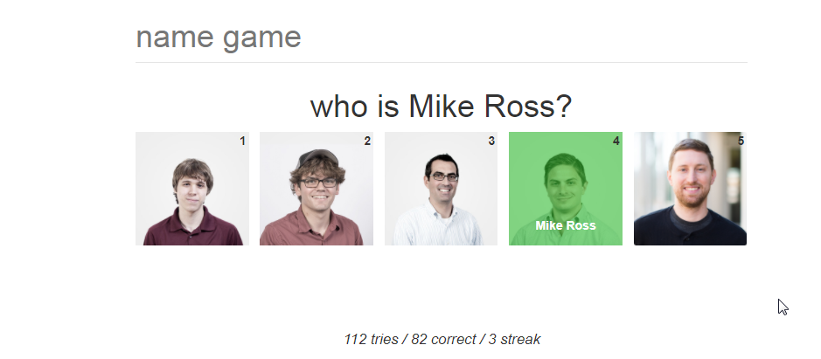

2

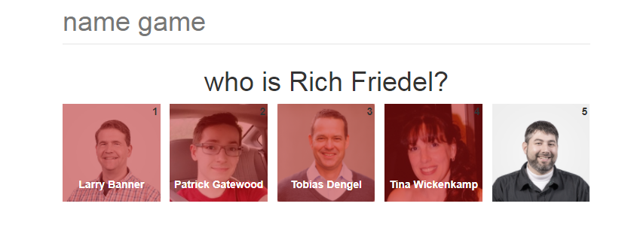

3



Then…



4



5



6

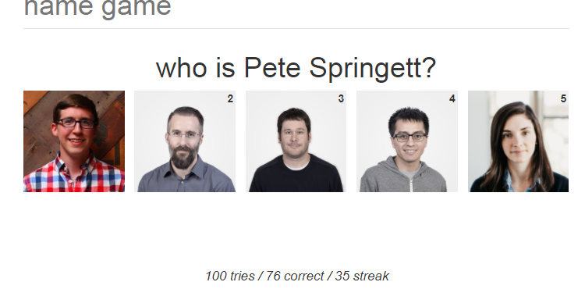

10.



1. First..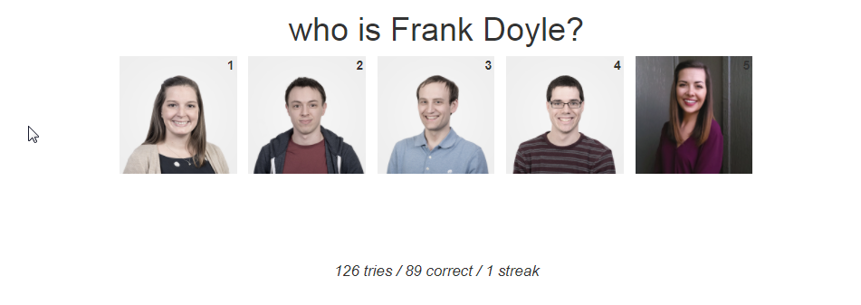

Then..

